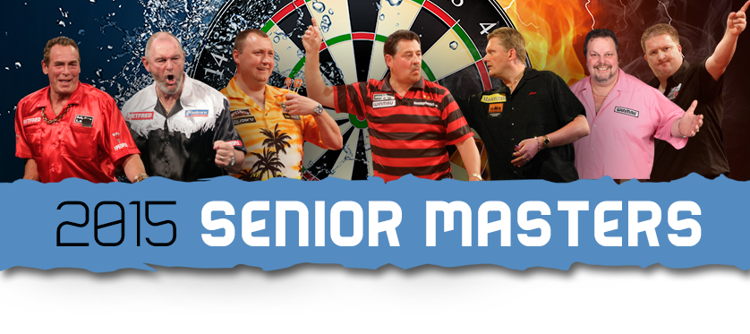

**CONFIRMATION FORM**

|  |  |  |  |
| --- | --- | --- | --- |
| **CONTACT NAME:** |  | | |
| **COMPANY:** |  | | |
| **ADDRESS:** |  | | |
|  | | |
|
| **TELEPHONE NO:** |  | **EMAIL:** |  |

|  |  |  |  |
| --- | --- | --- | --- |
| **Package Required:** | **Carlisle** | **Manchester** | **Any Additional information**  **e.g. Dietary requirements** |
| Bulls Eye - Sponsorship £2,000  Table x 10 (per event) |  |  |  |
| Game on - Associate Sponsor £1,000  Table x 10 (per event) |  |  |  |
| Table x 10 - £500 |  |  |  |
| Auction/Raffle Prize - Donation |  |  |  |

Please return this form by email to Carol Milnes [carol@ca-events.co.uk](mailto:carol@ca-events.co.uk)

Telephone carol for further information: 077142 11135

**Dress Code: Black Tie & Evening Dress**

**Supporting Breast Cancer Research**